Sunday, September 20, 2026 8:00 AM to Friday, September 25, 2026 5:00 PM CST
Category: National Certification

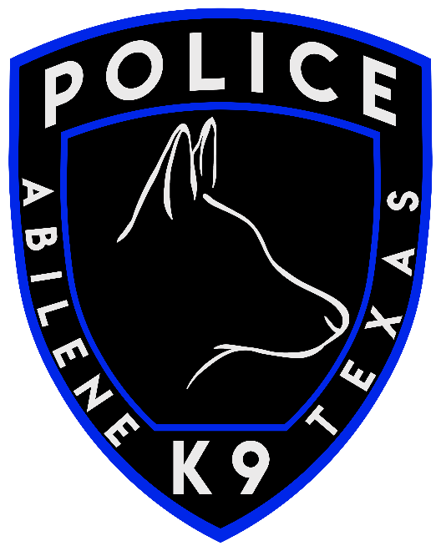
2026 National Field Trials
Hosted by Abilene, TX Police Department USPCA Region 25
Dates: September 20th - 25th, 2026
Tentative Agenda will be coming with more information.
Book your hotel by SEPTEMBER 11th. The hotel is the Double Tree by Hilton Abilene, Downtown Convention Center. 500 Cypress St in Abilene.
You can make hotel reservations via this custom booking link: 2026 USPCA National Canine Trials OR by calling the hotel directly 1-325-999-1878. Be sure to reference the USPCA 2026 National Canine Trials with the dates. (Sept 19th - 26th) Room and Tax will be paid by individuals and each reservation must be secured by CC. Group rate $169.
National Trial Registration Fee is $200. Awards Banquet fee is $25 per person.
REGISTER HERE
More information will be released as it becomes available.
Contact: Joshua New USPCA Region 25 joshua.new@abilenetx.gov

