Sunday, May 03, 2026 8:00 AM to Wednesday, May 06, 2026 5:00 PM EST
Category: National Certification

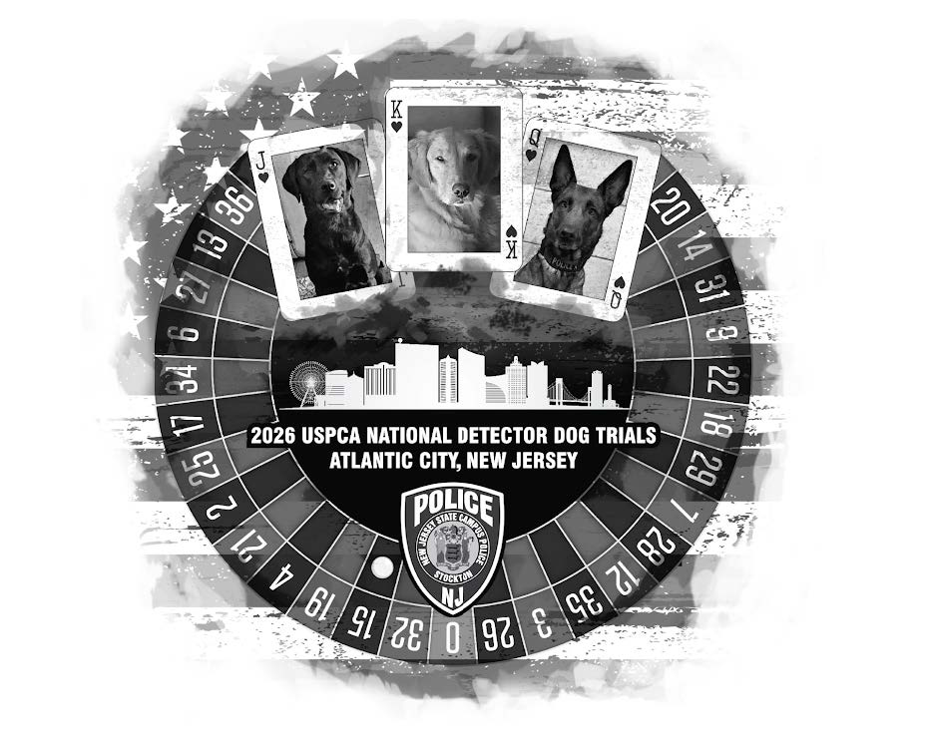
USPCA
National Detector Trials
Stockton University Police Department is proud to be the Host of the 2026 National Detector Dog Trials!
This years event will be held in Atlantic City, NJ campus of Stockton University. This will be an exciting event, in an EXCITING place and we look forward to seeing what Stockton University and Atlantic City has to offer!
Trial dates are May 3rd (registration and meeting day) to May 6th, 2026
REGISTER HERE ( you must PRE REGISTER to attend)
Certification fee is $200.00 Each banquet ticket is $25.00
Wonderful hotel accommodations are provided by: Harrah's Resort Atlantic City
Hotel address: 777 Harrah's Blvd, Atlantic City, NJ 08401 Rooms: $100 plus tax per night for Sunday night through Wed Morning. If you wish to come in on Saturday May 2nd, the room rate for that night is $174 plus tax. Room reservation can be made using the online link here: HOTEL RESERVATION (easiest) or by phone at 888-516-2215 (8 am to 2 am EST, 7 days a week) Group name: USPCA National Detector Dog Trial Group Code: SH05DD6 You will be asked for this code or you can tell them "USPCA National Detector".
If you remember, Stockton Univ. hosted back in 2018 and it was an amazing event, so we can't wait to see what Tracy and her helpers come up with this time!
Thank you to Tracy Stuart and the rest of her help!
Schedule of Events (Subject to minor changes)
Sunday May 3rd:
Arrival and check in - 10am - 4 pm
Vendor load in - 10 am to 5 pm
National Executive Board Meeting 0900
EOD testing odors - 1 pm to 3 pm
Narc testing odors - 1 pm to 3 pm
Judges meeting - 2 pm - 4 pm
General Membership/Handlers meeting - 4 pm - 6 pm
Hospitality - 6 pm
MONDAY MAY 4th
Explosives - ORT, Vehs, rooms, packages - 0800 hours
Hospitality at The Pool 6:30 pm
TUESDAY MAY 5th
Narcotics - Veh and Rooms - 0800 hours
HRD/Accelerant as needed
Hospitality 6:30 pm
WEDNESDAY MAY 6th
Awards Banquet - 0900 hours

Contact: Tracy Stuart tstuart46@gmail.com

